ORAL/SALIVA FLUID LAB TEST INSTRUCTIONS:
All information provided on the “Test Request & Chain of Custody Document” submitted with the specimen, is completely confidential and cannot be shared with anyone else without specimen ID #.
Please follow the instructions below to avoid unnecessary delays in processing or testing your specimen. If you have any questions regarding these instructions, please contact Medimpex Untied, Inc. Customer Service at 1-866-848-8378 for assistance.
COMPLETING THE TEST REQUEST & CHAIN OF CUSTODY DOCUMENT
1. Complete the Test Request & Chain of Custody Document: Must include...the donor’s name, SS# or ID#, date of birth, name/address of the collector and date of the collection. Both the donor & collector must date & sign.
2. The testing options available with Oral Specimens Include: (located in the TEST REQUEST section of Test Request & Chain of Custody Document)
[ ] {1094} Oral/Saliva 12 Panel Lab Test: SCREENING / CONFIRMATION (DOA-SALAB)
[ ] { 92 } Oral/Saliva 5 Panel Lab Test: SCREENING / CONFIRMATION (DOA-SLAB5)
3. An “X” will indicate which test you have purchased (completed by Customer Service at time of purchase).
COLLECTING THE SPECIMEN
4. Oral fluid specimens cannot be collected within ten minutes of the donor eating or drinking. Grasp the handle and position the cotton pad under the donor’s tongue. During the collection process, donors cannot talk, chew on the pad, or remove the collection device until the Volume Adequacy Indicator turns BLUE (2-5 minutes)…as shown on packaging.
5. Discard the device if the indicator has not turned BLUE after 10 minutes. Instruct the donor to drink water, wait 10 minutes, and then repeat the test with a new collection device.
6. After the indicator turns blue, hold the transport tube upright, unscrew the red cap and place the collection device (pad first) into transport tube. Replace the red cap and push down until it SNAPS into place.
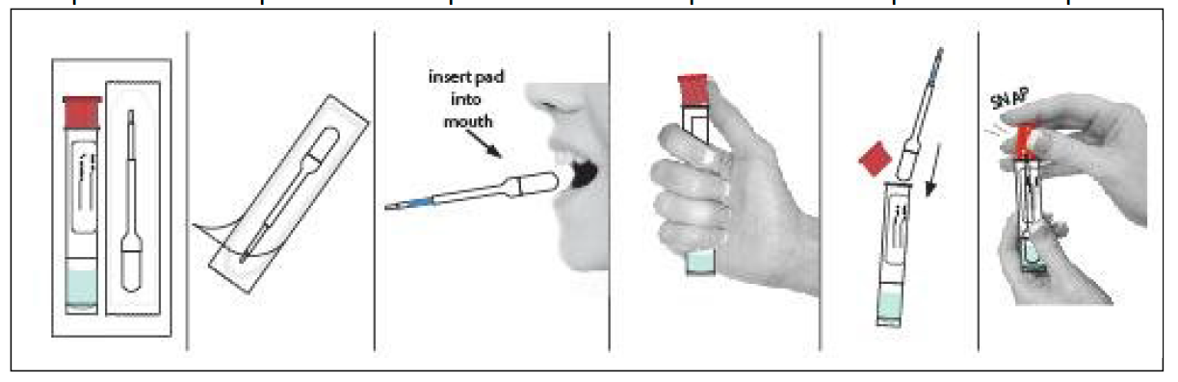
SECURING AND SHIPPING THE SPECIMEN
7. Secure the specimen by placing the initialed and dated security SEAL (found in the middle of the Test Request & Chain of Custody Doc), over the top of the specimen down the smooth sides of container.
6. Place the sealed specimen container in the small pouch of the bio-hazard bag. Fold and place the white copy of the Test Request & Chain of Custody Doc into the large pouch of the bio-hazard bag. Remove the plastic tape, from the adhesive strip and fold over the flap to seal the bio bag. Retain the yellow copy of the Test Request & Chain of Custody Document for your records.
8. Place the sealed specimen bag into the shipping box provided. The enclosed sticker with “Exempt Human Specimens” must also be placed on the box in a location that does not cover the shipping label (may already be affixed to shipping box).
9. Once the box has been prepared for shipment, ship it to the address below using the provided pre-paid USPS shipping box.
Medimpex /Cor
1760 E. Route 66 Ste. 1
Flagstaff, AZ 86004

